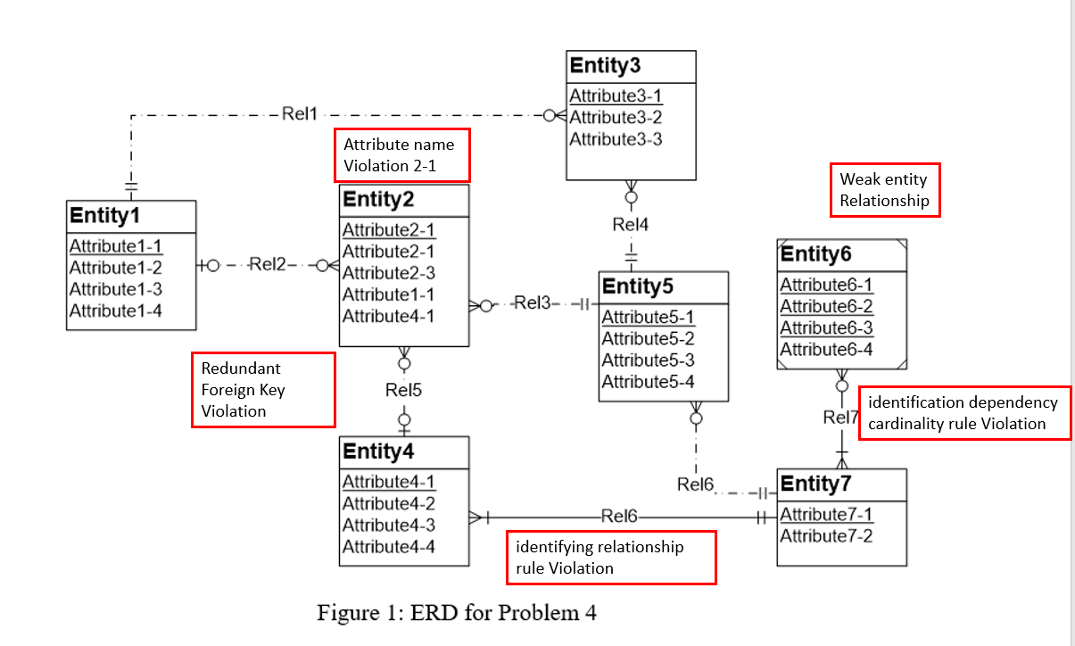

* Resolution of the redundant FK rule: removing the redundant foreign keys (Entity2.Attribute4-1 and Entity6.Attribute1-1). If the attribute does not represent a foreign key, it should be renamed instead of removed.
* Attribute name violation : Attributes of same name used.
* Resolution of the identification dependency cardinality rule: The problem can be resolved by changing the weak entity’s cardinality in Rel7 to (1,1).
* Resolution of the weak entity type rule: The problem can be resolved by either adding one or more identifying relationships or by changing the weak entity (Entity 6) into a regular entity.
* Resolution of the identifying relationship rule: The problem can be resolved by adding one or more weak entities or making the relationship (Rel6) non-identifying.